Design and Implementation of Any Time Electricity Bill Payment(ATP)Machine Controller

|  |  |  |
| --- | --- | --- |
|  |  |  |
| Vivekanandan.M  Assisant Professor  Department of Artificial Intelligence *and Data science*  Rajalakshmi Institute of Technology vivekanandan.in@ritchennai.edu.in    Sri Ganesh.S  Artificial Intelligence and Data Science  Rajalakshmi Institute Of TechnologyChennai,India sriganesh.s.2021.ad@ritchennai.edu.in | O.Pandithurai  Associate Professor  Department of Computer Science and  Engineering  Rajalakshmi Institute of Technology  pandies@ritchennai.edu.in    Rishikesh.K  Artificial Intelligence and Data Science  Rajalakshmi Institute Of Technology  Chennai,India  rishikesh.k.2021.ad@ritchennai.edu.in | G.Sai Krishnana  Department Of Mechanical  Engineering  Rajalakshmi Institute Of Technology saikrishnan.g@ritchennai.edu.in    Nitheesh.S  Artificial Intelligence and Data Science  Rajalakshmi Institute Of Technology  Chennai,India  nithesh.s.2021.ad@ritchennai.edu.in |

**ABSTRACT**

Anytime Electricity Bill Payment Controller is a system designed to facilitate convenient and flexible electricity bill payment options. It allows users to pay their electricity bills anytime, anywhere using various payment methods. The driver ensures seamless integration between the user, energy service providers and payment gateways, enabling fast and secure transactions. This abstract highlights the key features of Anytime Electricity Bill Payment Controller andhighlights its ability to provide a user-friendly interface, support multiple payment channels, and ensure real-time payment processing, increasing the overall convenience and efficiency of electricity payments.

**INTRODUCTION**

Anytime Electricity Bill Payment is a modern and convenient system that allows users to pay their electricity bills anytime, anywhere. It provides a user-friendly platform that simplifies the bill payment process and offers multiple payment options to cater to different user preferences. The system ensures payment processing in real time, eliminates the need for manual intervention and shortens payment processing time.With Anytime Electricity Bill Payment, users can easily view their bills, make secure transactions and receive instant payment confirmations. This system aims to increase the overall convenience and efficiency of electricity payments and facilitate efficient account management for users.

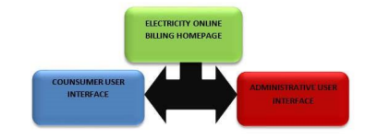

**LITERATURE SURVEY**

Birendrakumar Sahani.al [1] IoT based smart energy metering implementation model. The proposed model is used to calculate household energy consumption and even makes it easier to read the energy department. It reduces energy consumption and brings about overall awareness.

Mayur Rawte.al [2] is a system designed to solve many problems such as electricity consumption, high labor transparency, and money and resource consumption. This technology allows verified customers to monitor their electricity usage. Real-time device identification number and password. This can be done from a web application using the internet.

The Nazmat Toyin.al system [3] is designed to refer to a local server and database, and when the Internet connection is restored, all data is synchronized with the web server. The booking is done locally by the web server and there is no online payment platform connected to the agency.

Mst. Shahnaj Parvin.al [4] explains the framework and how it can be useful in detecting illegal electricity usage. The comparative advantages of the proposed system also shown in the paper on conventional systems.

Azfar Tufail.al [5] provides an improvement in the traditional measurement system through smart measurement. The term "Smart Meter" is an advanced energy meter that measures electricity consumption, providing additional information compared to standard energy meters.

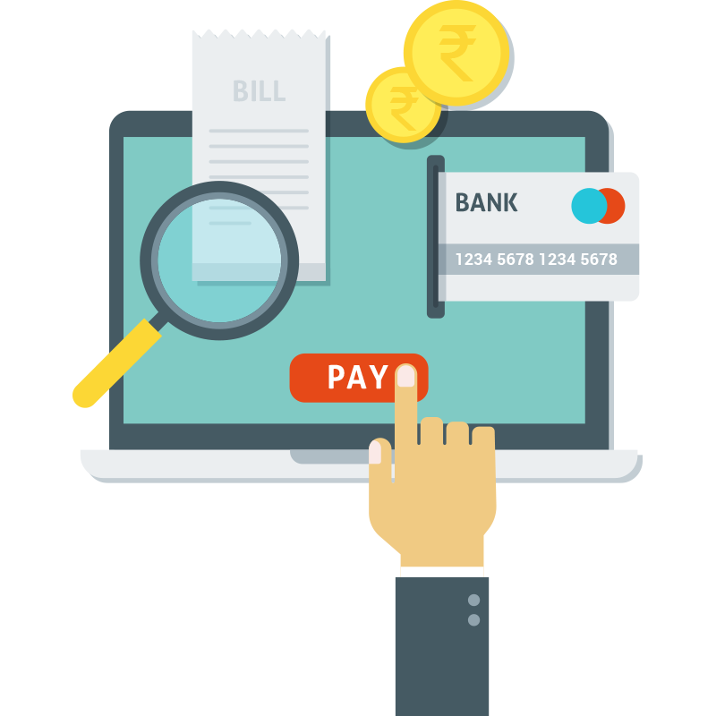

**ProposedSystem:** Considering the anomalies into the existing system, a computerized system is built using Asp.Nnet with C# as a base language. The system enhances and upgrades the old existing system by increasing its efficiency and effectiveness. The software improves the working methods by replacing the existing manual system with the computer-based system. The proposed system automates each and every activity of the manual system and increases its throughput. Thus the response time of the system is less and works very fast. The system uses a quick response with very accurate information regarding the user’s electricity bill information. The proposed system has a very user friendly interface, thus the user will feel very easy to work on it. The software provides accuracy along with a pleasant interface. The transactions reports of the system can be retried as and when required. Thus there is no delay in the availability of any information, as whatever will be needed, can be captured quickly and easily. The Microsoft Visual Studio will be used as a front end and The Microsoft Structured Query Language (SQL) as back end for developing the project. Visual studio is primarily a visual design environment. This design environment will be used to create text boxes, buttons and adding support codes in the respective modules (the administrator and user modules). The Microsoft SQL server is a powerful database application with which the user can efficiently create and manipulate database systems.

**OBJECTIVES**

In short, the purpose of Electricity Bill Payment Controller is to simplify the bill payment process, ensure timely payment, and provide a convenient and easy-to-use platform for users to manage and settle electricity bills.

**CHALLENGES**

Challenges for electricity payments at any time include ensuring security and privacy, integration with utility providers, supporting multiple payment channels, managing infrastructure and technical scale, gaining user acceptance and trust, meeting payments, and technical support and maintenance.

**ARCHITECTURE**

In short, the "Anytime Electricity Payment Controller" architecture includes a user interface for users to enter the system, a payment gateway to manage transactions, an integration layer to communicate with utility providers, a security component for data protection, and a database. for storage. user data and payment, alert system for updates, and analytics module to generate reports.

**1) Block Diagram:**

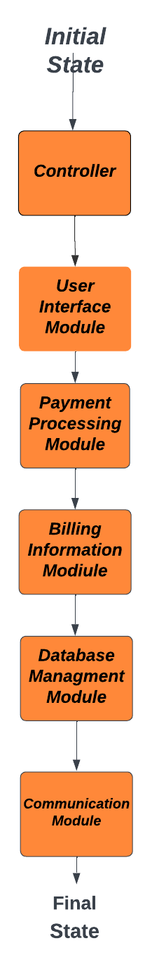-

**2) States:**

* Initial State: Represents the starting point of the FSM.
* Payment Selection State: User selects the payment method (e.g., credit card, bank transfer).
* Payment Confirmation State: User confirms the payment details.
* Payment Processing State: Payment is being processed.
* Payment Success State: Payment is successfully completed.
* Payment Failure State: Payment fails due to an error or insufficient funds.
* Error State: Represents an exceptional or error condition.

**3) Events:**

* Payment Method Selected: Triggered when the user selects a payment method.
* Payment Details Confirmed: Triggered when the user confirms the payment details.
* Payment Processed: Triggered when the payment processing is completed.
* Payment Successful: Triggered when the payment is successfully processed.
* Payment Failed: Triggered when the payment processing fails.
* Timeout: Triggered when a specific time limit is reached.

**4) State Transition Logic:**

* Initial State -> Payment Selection State: Payment Method Selected event.
* Payment Selection State -> Payment Confirmation State: Payment Details Confirmed event.
* Payment Confirmation State -> Payment Processing State: Payment Processed event.
* Payment Processing State -> Payment Success State: Payment Successful event.
* Payment Processing State -> Payment Failure State: Payment Failed event.
* Payment Success State -> Initial State: Timeout event.
* Payment Failure State -> Initial State: Timeout event.
* Payment Failure State -> Error State: Payment

Failed event.

**5) Data and Context Management:**

* Store payment details, such as payment method, amount, and user information.
* Keep track of the payment processing status and any error messages.
* Maintain a timer for handling timeouts and ensuring system responsiveness.
* Input and Output Interfaces:
* User Interface: Allows users to select payment methods, provide payment details, and view payment status.
* Payment Gateway Integration: Interfaces with external payment gateways for processing payments.
* Billing System Integration: Interfaces with the utility company's billing system to update payment status.

**6) Error Handling and Recovery:**

* Handle exceptions and errors during payment processing.
* Provide appropriate error messages to the user.
* Implement retry mechanisms or recovery procedures for failed payments.

**7) Integration with the Larger System:**

* Integrate with the utility company's billing system to retrieve billing information and update payment status.
* Communicate with the user authentication system for secure user login and authorization.
* Integrate with the payment gateway APIs for processing payments.

**8) Testing and Validation:**

* Develop test cases to validate the behavior of the FSM in different states and events.
* Perform integration testing to ensure seamless communication with external systems.
* Conduct robustness testing to handle exceptional scenarios and edge cases.

**HARDWARE AND SOFTWARE**

At any given time, the hardware components of an electric bill controller include servers, network infrastructure, storage devices, and security devices.

Software components include user interfaces, payment gateway software, database management systems, integration middleware, security software, and analytics tools.

**CONCLUSION**

Pay Electricity Anytime offers users an easy and flexible solution to pay electricity bills anytime and anywhere. By providing a user-friendly interface, supporting multiple payment channels, enabling real-time payment processing and maintaining strong security measures, this system increases the convenience and efficiency of electricity payments. With seamless integration between users, utility providers and payment gateways, Anytime Electricity streamlines the billing process, reduces manual intervention and improves user satisfaction.

**REFERENCE**

[1] <https://www.researchgate.net/publication/337275192_DESIGN_AND_IMPLEMENTATION_OF_AN_ELECTRICITY_ON-LINE_BILLING_PAYMENT_SYSTEM>

Arimoro, T. A., Oyetunji, A. K., & Odugboye, O. E.

(2019). Analysis of Electricity Billing System in

Corporate Buildings in Lagos, Nigeria. Studies, 1(6),

10-20.

Arimoro, T. A., Oyetunji, A. K., & Odugboye, O. E.

(2019). Analysis of Electricity Billing System in

Corporate Buildings in Lagos, Nigeria. Studies, 1(6),

10-20.

Arimoro, T. A. , Oyetunji , A. K., & Odugboye, O. E. (2019). Analysis of Electricity Billing System in Corporate Buildings in Lagos , Nigeria. Studies, 1(6), 10-20.

[2] https://www.ijert.org/implementation-of-iot-based-electricity-controlled-prepaid-energy-meter-monitoring-and-bill-payment-system

**[3]** <https://www.gbv.de/dms/ilmenau/toc/189363606laker.PDF>

Electricity Network Distribution Design by E. Lakervi and E. J. Holmes

[4] https://powermin.gov.in/en/content/national-electricity-policy

[5] <https://www.studocu.com/in/n/24819319?sid=01689314448>

Smart Grid by James Momoh for the design and implementation

[6]

<https://www.academia.edu/47540213/IJERT_Implementation_of_IOT_based_Electricity_Controlled_Prepaid_Energy_Meter_Monitoring_and_Bill_Payment_System>